Assignment B.8 - Milligan Chapter 9

Student Name: | < Replace this text with your name >

Week 4 - Milligan Chapter 9

Welcome to your hands-on activity! This assignment invites you to work with Tableau using a mix of generated and real-world data. You will:
- Download the attached spreadsheet and upload those data sets into Tableau. If you need help loading your data sources, refer to Assignment A.2 for help.
- Go through this document and use Tableau to answer all the questions listed below. Where applicable, paste screenshots into the template below.
- When you are ready, complete the online quiz which verifies your homework. You are welcome to refer to this document when you complete the quiz.
- You are welcome to use the quiz results to update your homework file.
- When you have completed the online quiz, submit the Word document.
- Remember, you can always reach out for help to your instructor if needed.
- If you need to adjust the size of your visualizations to match the options in the questions, use the “Format”->” Cell size” options. For example, “Ctrl+Shift+B” on a Windows computer will make the visualization bigger and “Ctrl+Up” will make it taller.

The spreadsheet attached to this assignment contains five datasets:

- B.8 Real Estate Listings
- B.8 San Francisco Sales Data
- B.8 Happiness Survey employees
- B.8 Employee Attrition data
- B.8 NW National Park Visitation 2001-2020

Question 1: Linear Trend

You are working on an analytics team that is contracted by a real estate sales company in San Francisco that wants to perform an analysis of the MLS data. You are asked to show the relationship between square footage and the sales price of the data available. You were given the following instructions to find the relationship, but these are for a generic data set, so you will practice first with the data set: B.8 Real Estate listings and then you will create a trend line specific to San Francisco.

Connect to the B.8 Real Estate listings and highlight “Price” and “Size (Sq Ft)” at the same time-then under the “show me” menu, click on the scatter plot option.

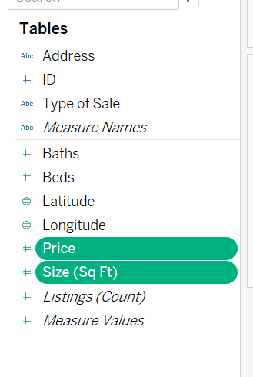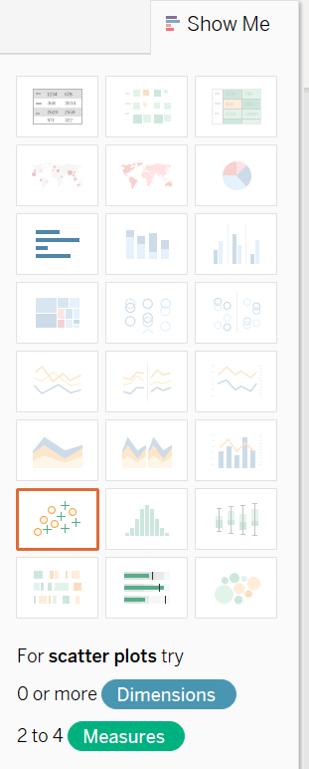
Under the analysis menu- turn OFF Aggregate Measures.

Now you should see a scatterplot of the Price and Square Feet.
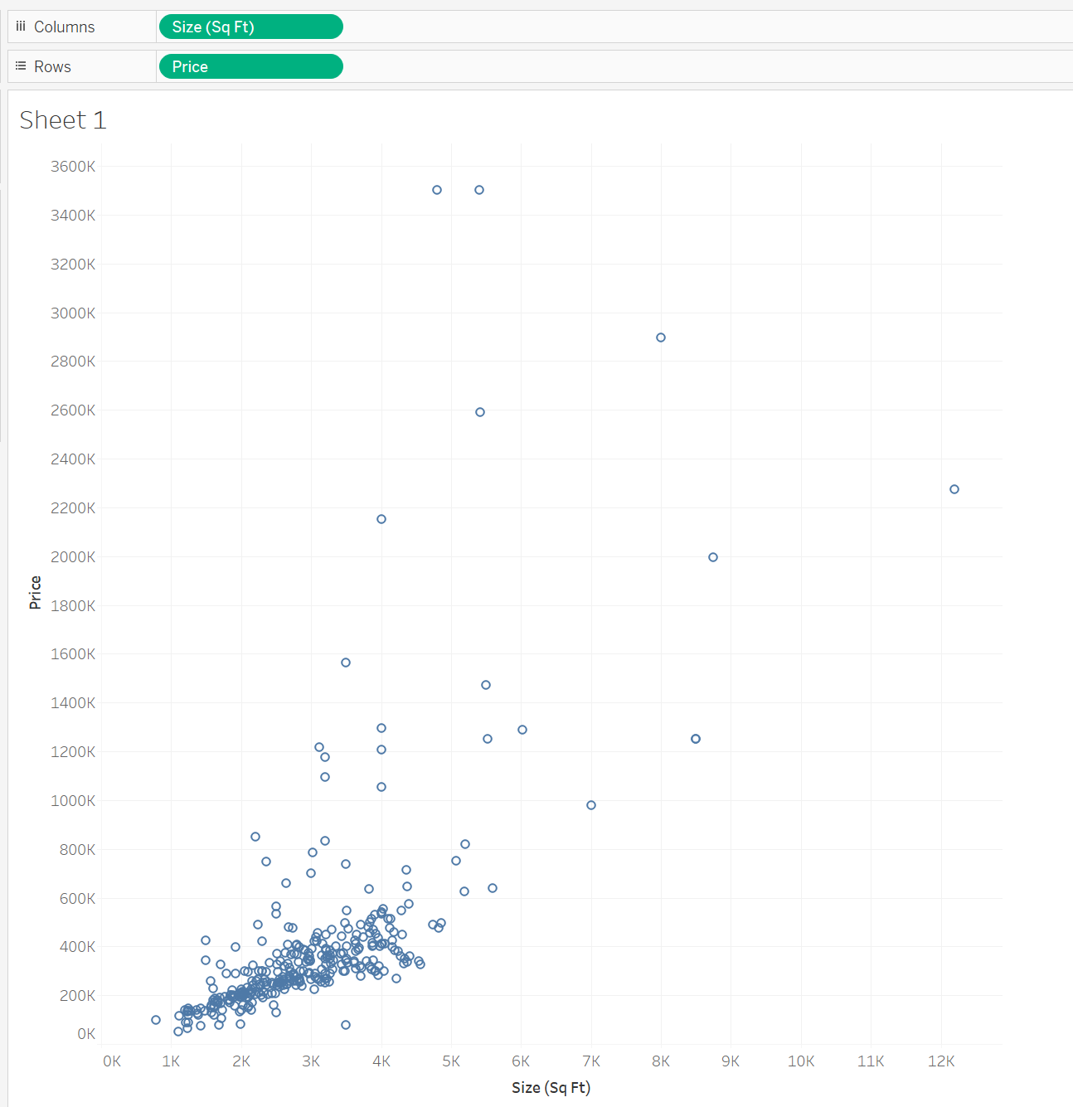

We can see from this that as the size increases, so does the price, so we will assume this is a linear relationship. Now we will add a trend line. Click on the Analytics tab.
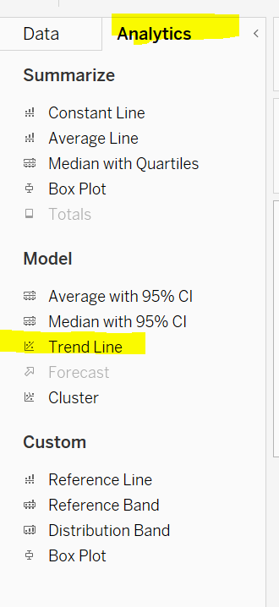
Then drag the Trend Line over to the scatter plot and pick the first option: Linear.

Now you should have a line over your scatter plot.

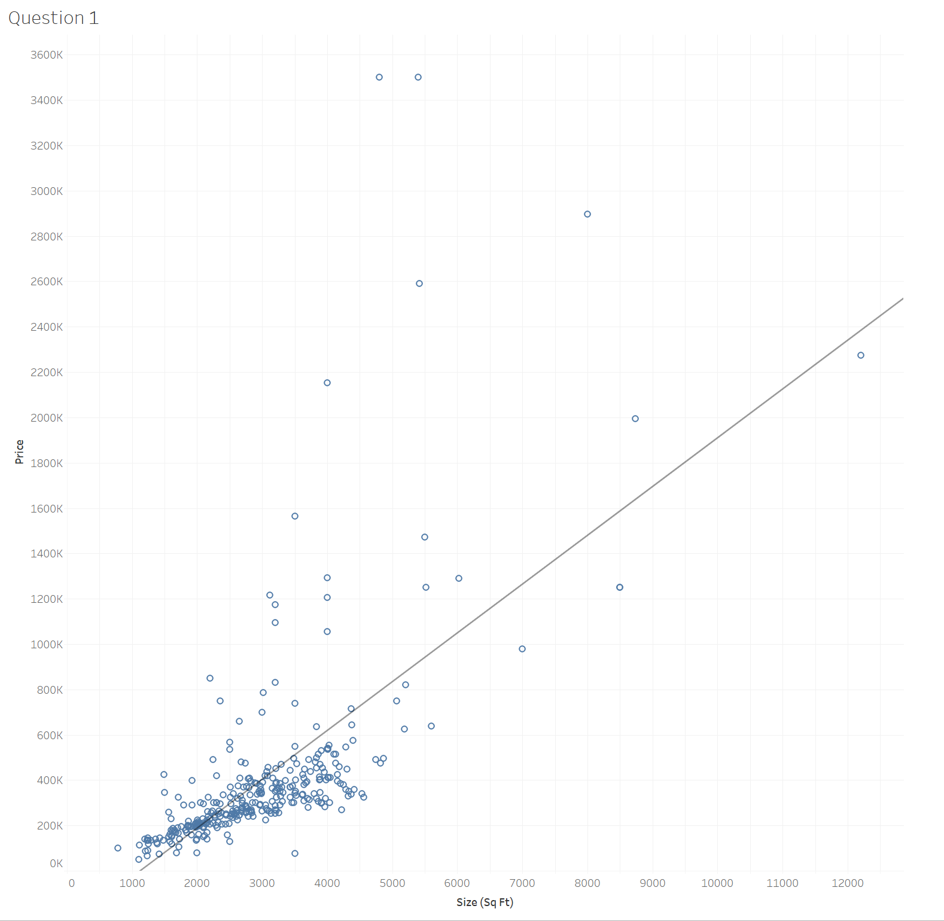

We now have an idea of the relationship between square feet and price. Now, you will perform this same visualization and trend for the B.8 San Francisco sales (use Sf for square feet and Sale Price for price).
Which of the following images shows a linear trend line of the San Francisco real estate data?

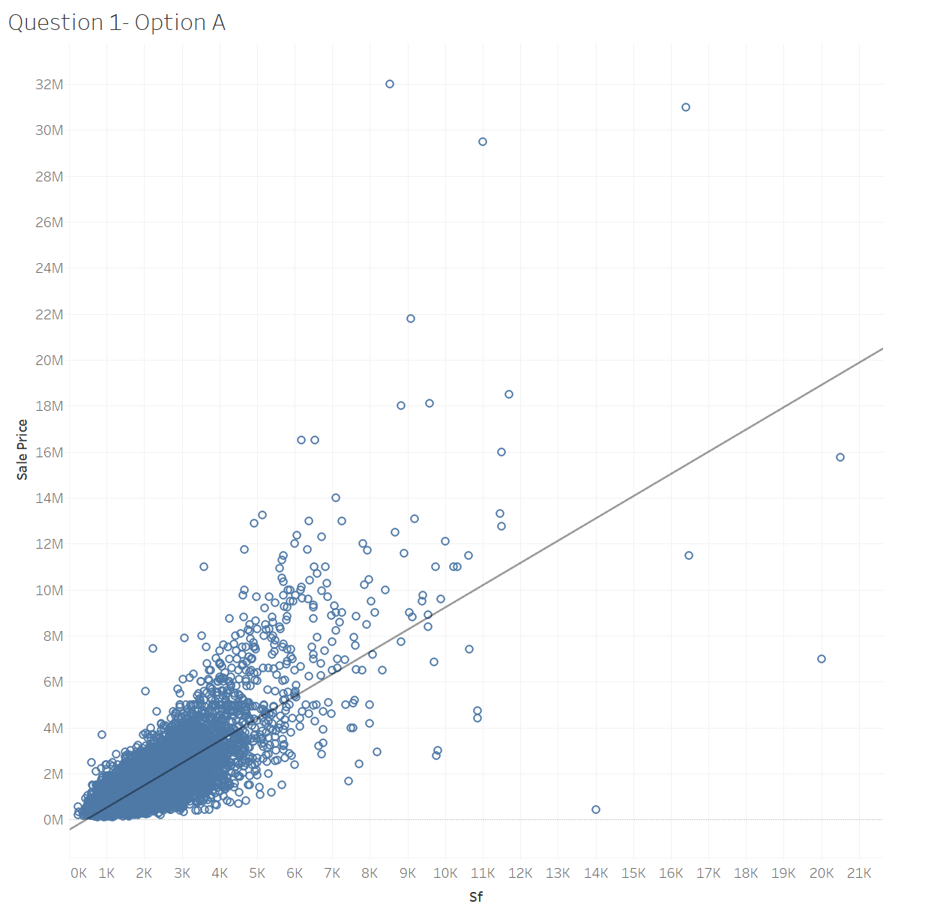 | 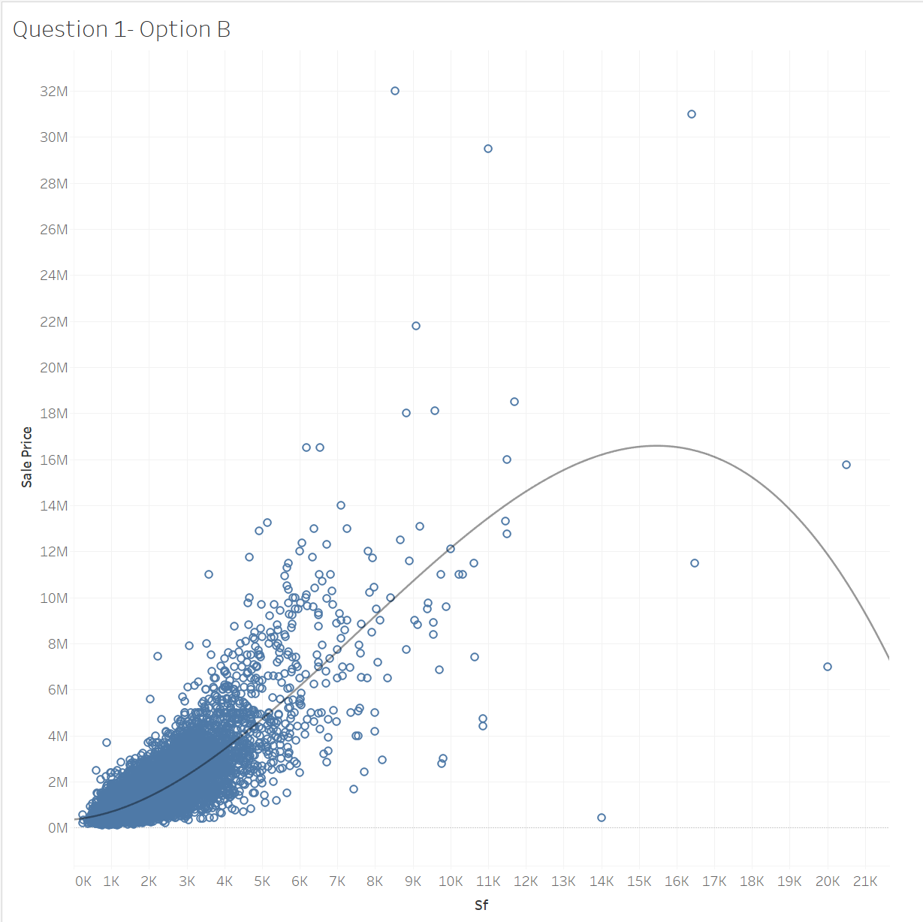
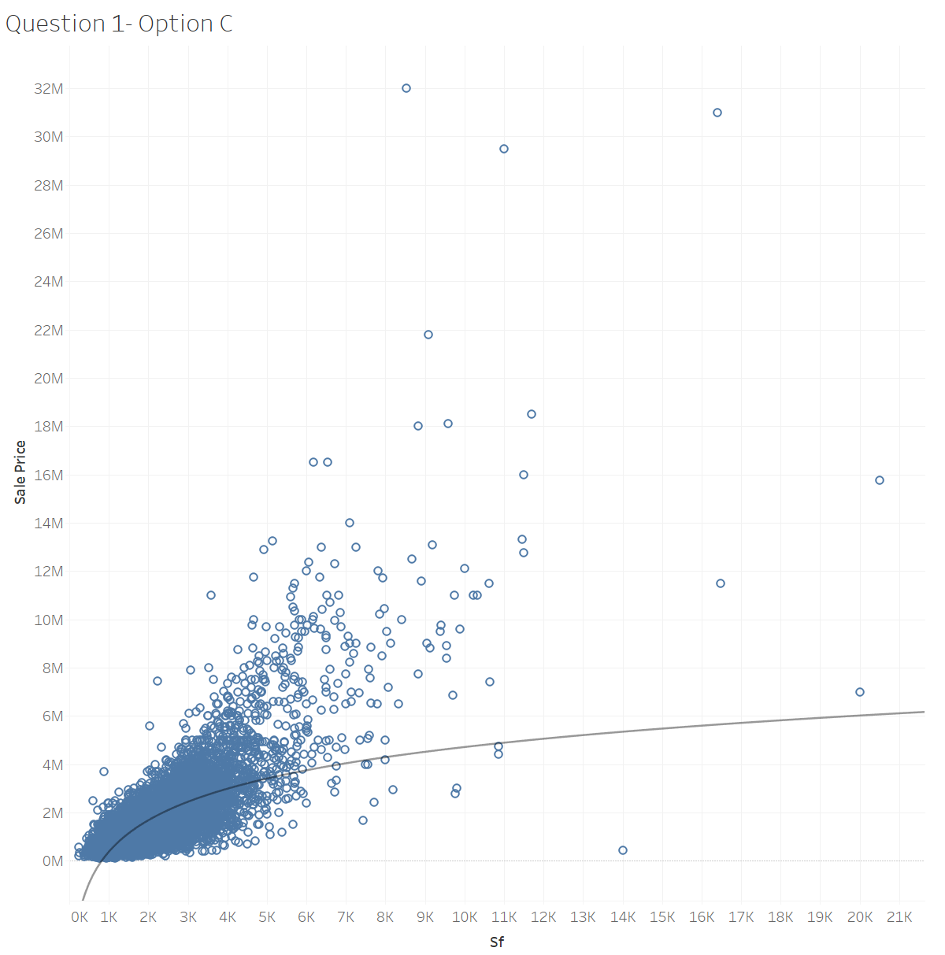 | 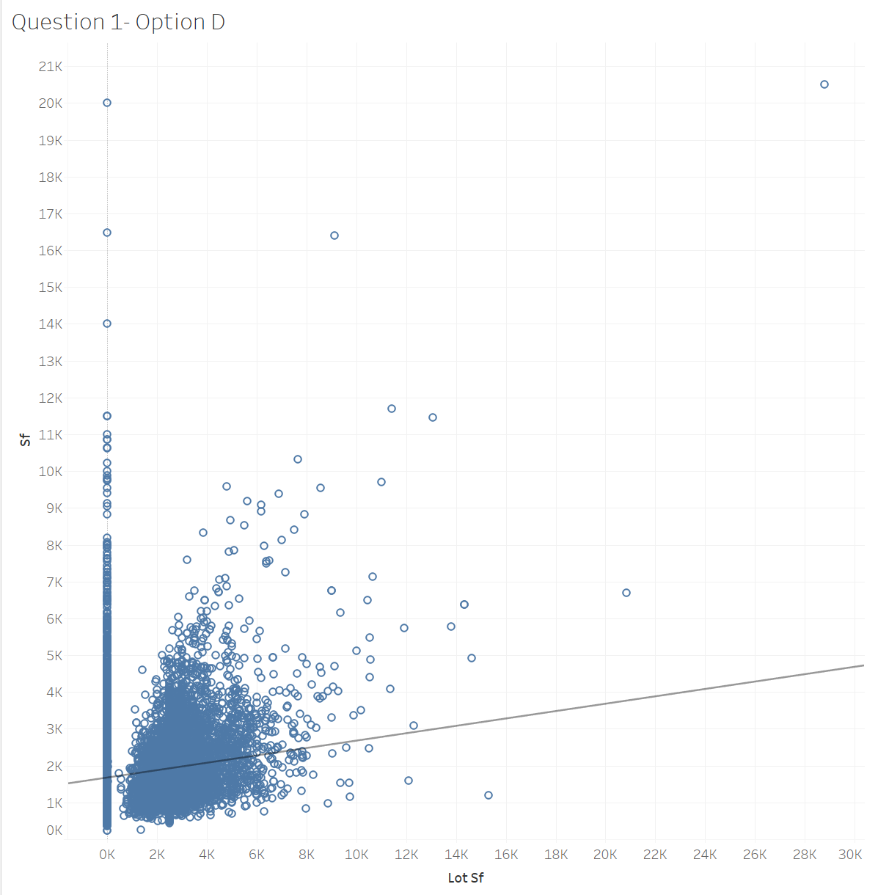

Question 1 Answer: | Option A

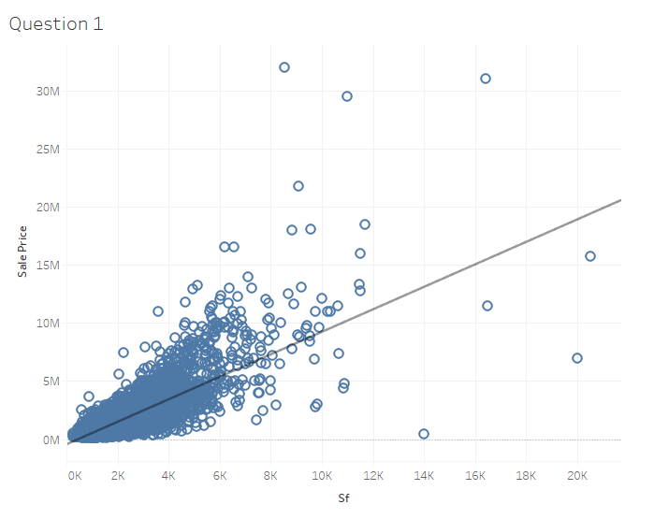

Question 2 (parts A &B): Interpreting linear trend statistics

Before we share this with our audience at the real estate company, we need to look at the statistical summary behind the data. If we go back to the B.8 Real Estate Listing, we can right-click on the linear trend line and choose “Describe Trend Model”
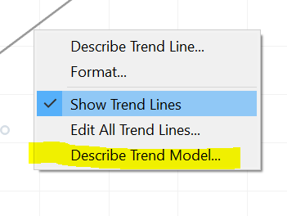

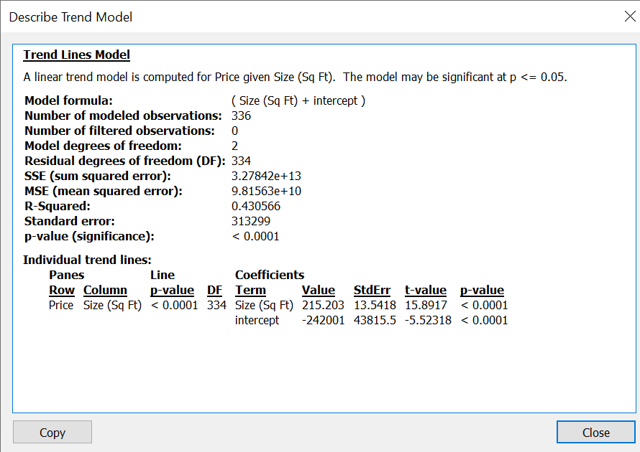

Generally speaking, when we see that the p-value is less than 0.05, we know that the model is considered statistically significant and that there is a low chance that the data occurred by random chance. Our p-value is less than 0.0001, which is a lot smaller than 0.05, so we have a statistically significant model.

We can also see the “innards” of this model. It is fitting the equation:

Price = m (Size in Sq Ft) + Intercept.

(If you remember a line as y=mx+b from algebra class, this is its grown-up cousin, in that the b = intercept and the x = size in square feet. You can think of the “b” as “how much you pay for the lot” and the “m” as “how much you pay per square foot.” In our case, the b is negative, so you calculate on a per-square-foot basis and then subtract a certain amount to get your final estimate. If you need a refresher on linear regression, check out this video from Khan Academy: https://www.khanacademy.org/math/statistics-probability/describing-relationships-quantitative-data/introduction-to-trend-lines/a/linear-regression-review )

You can plug in any given size in square feet, and it will calculate the price for you.

For example, if you want to price the first dwelling, our friends on Highway 360 in Mansfield, TX, you would see it’s a 2,300 square foot dwelling, and you would do something like this:
Price of home | = | Mx | + b
 | = | M (size in square feet) | + intercept
 | = | 215.203 (size in square feet) | - 242,001
 | = | 215.203 (2,300) | - 242,001
 | = | 494,966.90 | -242,001
 | = | 252,965.90

Now you should have a better understanding of the math behind a linear trend model. Create a linear trend model for the San Francisco sales data and describe the trend model for the San Francisco data.

Question 2A: Can we consider the linear trend line for San Francisco statistically significant?

Yes
No

Question 2A Answer: | Yes

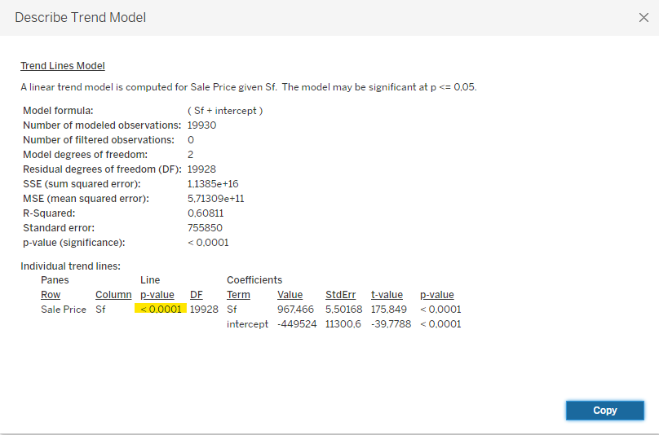

Question 2B: What is the price per square foot given by the San Francisco model?

Option A: 967.466
Option B: 119,930
Option C: 175.849
Option D: -449,524

Question 2B Answer: | Option A: 967.466

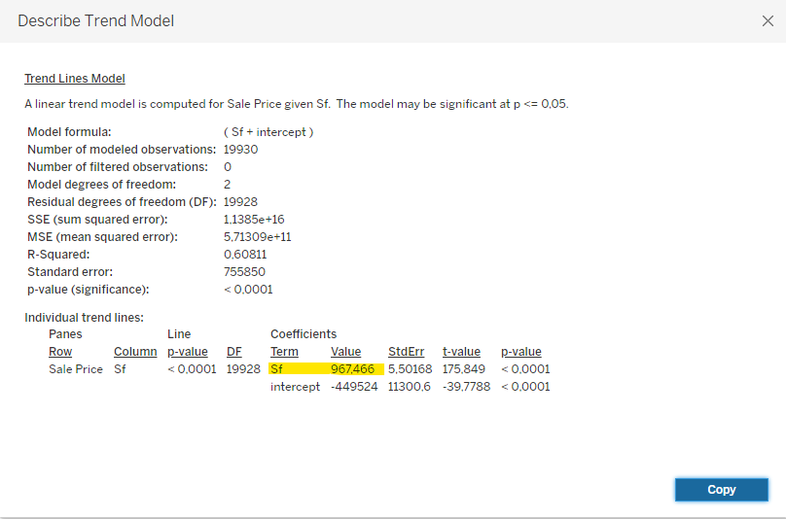

Question 3: Logarithmic trendline

You have a new client, a pharmaceutical company that wants to better understand its workforce. Someone in their leadership team read an article about the relationship between employee happiness and salary. They decided to survey their new entry-level employees to see how happy they are on a scale of 1-10 (1 being the least and 10 being the most). They were also asked about their salaries. The employees were part-time as well as full-time. This data is in B.8 Happiness Survey employees. Use the first tab, labeled January to load the data into Tableau.

First, you click on both the Happiness 1 and Income fields. Then click on the scatterplot option in the Show Me. Turn off the aggregation by going under the Analysis menu and unchecking aggregate measures.

You should have a scatterplot that looks like the following:

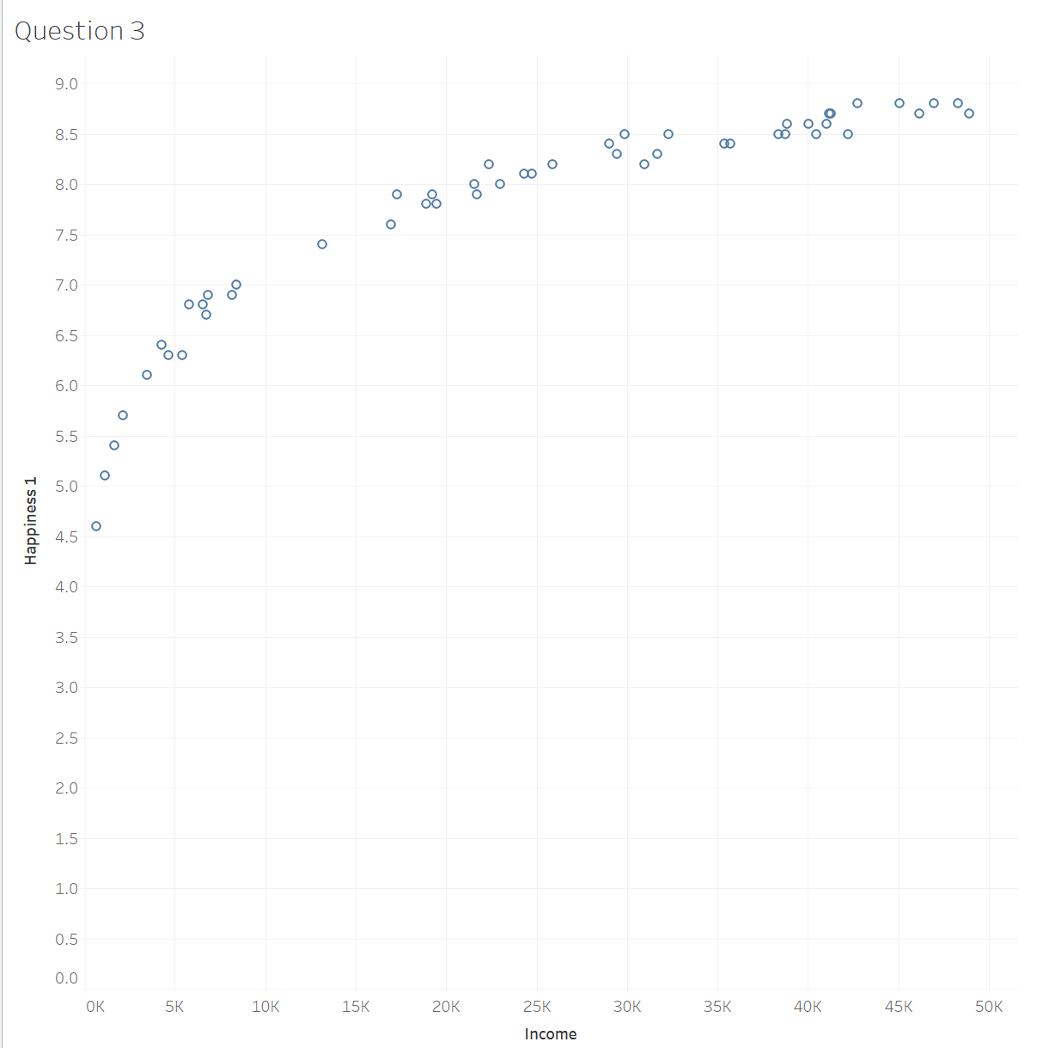

Now, go under the Analytics Tab and drag the Trend Line over the graph and select Logarithmic.
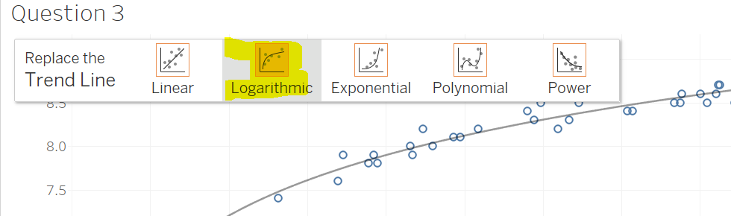

Right-click on the line that is created and click on “Describe Trend Model”, you will get a window pop-up like the following:
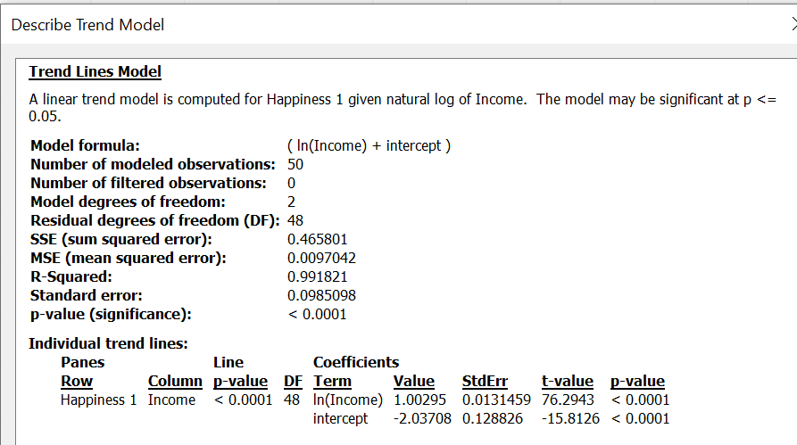

This model can be expressed with the following equation: y= 1.00295ln(x)-2.03708 with an R² = 0.9918. Y is the happiness level and X is the salary. If you need a refresher on the math, “ln” represents the natural log that uses the base of e. This video helps to explain as well: https://www.khanacademy.org/math/algebra2/x2ec2f6f830c9fb89:logs/x2ec2f6f830c9fb89:e/v/natural-logarithm-with-a-calculator. You can perform the ln calculation on a scientific calculator- you might have one on your computer already! We’ll show you the math below:

Y=Happiness Level | Coefficient ln (x=Income) + | Y-intercept
 | 1.00295 * ln (x) + | -2.03708
If we plug in Income =$1,000 | 1.00295 * ln (1,000) | -2.03708
Happiness Level= | 4.9
If we plug in Income =$10,000 | 1.00295 * ln (10,000) | -2.03708
Happiness Level= | 7.2 (2.3 more than $1,000)
If we plug in Income =$20,000 | 1.00295 * ln (20,000) | -2.03708
Happiness Level= | 7.9 (0.7 more than $10,000)
If we plug in Income =$30,000 | 1.00295 * ln (30,000) | -2.03708
Happiness Level= | 8.3 (0.4 more than $20,000)
If we plug in Income =$40,000 | 1.00295 * ln (40,000) | -2.03708
Happiness Level= | 8.6 (0.3 more than $30,000)
If we plug in Income =$50,000 | 1.00295 * ln (50,000) | -2.03708
Happiness Level= | 8.8 (0.2 more than $20,000)

As you can see, the employees that were paid the least, probably the part-time employees had the least happiness and lowest salaries. We can see a big jump in happiness from employees paid very low to 10K. Then when we go from $10K to $20K, their happiness rating only goes up 0.7 on the scale. Eventually, for the employees paid the most in the survey, the additional money barely makes a difference in their happiness. This can also be described as a law of diminishing returns. Where you are seeing big differences in one variable (happiness in this case) as the salary increases, but eventually it levels out.

The leadership at the company is very interested in this and decided to resurvey their employees in June one more time to make sure the data is still consistent. You will be performing the same steps but on the June Survey data in the B.8 Happiness Survey employees data source.

When you create a logarithmic trend line for the June survey, what is the value of the coefficient on income that was calculated?

Option A: 0.97778
Option B: 1.34142
Option C: -2.21811
Option D: 1.02523

Question 3 Answer: | Option D: 1.02523

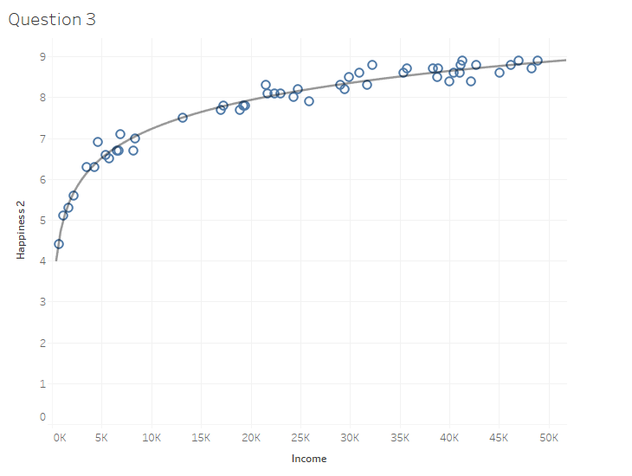

Question 4: Exponential Trend Lines

The pharmaceutical company has a new set of data: B.8 Employee Attrition Data to help the pharmaceutical company analyze all their employees. This time, you have been asked to look at the relationship between Monthly Income (USD) and Total Working Years. They would also like to see this by education level.

Create a scatterplot with these two fields following the steps you took in Questions 1 and 3. Next, add an exponential trend line.
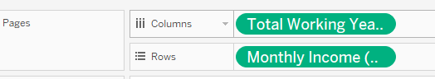
Review the p-values for the 5 levels.
Move “education” over to the color marks. You should now have 5 exponential trend lines.

Move “education” into the filter and select “Below College”, you should now have one trend line and one color in your graph.

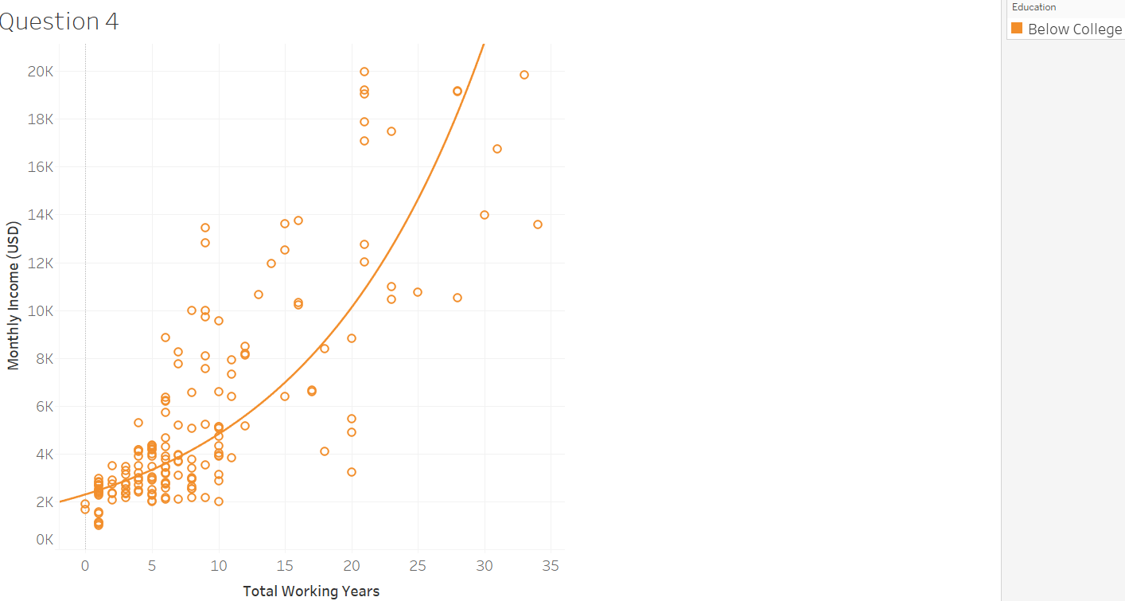

Using the line, we can say that after 15 of working, employees with an education level below college will earn around $7K per month.

Now, change the filter to “Master” and examine the new trend line. Using the trend line for the employees with a master’s degree, what would you approximate the monthly income of an employee with 20 years of experience?

Option A: $7K
Option B: $14K
Option C: $6K
Option D: $9K

Question 4 Answer: | Option D: $9K

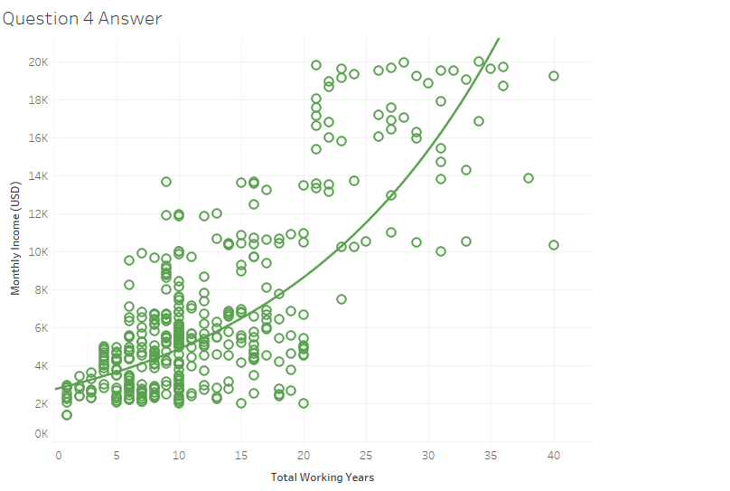

Question 5: Clusters

The pharmaceutical company that you are working with would like to create groups of employees that have similarities between them. The goal is to provide incentives and professional development that are customized to the characteristics of the employees in each group. You will be using the clusters feature to provide them with groups of employees.

Click on the measures “Training Times Last Year”, and “Years Since Last Promotion”. Remember to click on the Ctrl button to hold them all down. Then click the Scatterplot on the Show Me menu and remember to turn off aggregate measures in the Analysis menu.

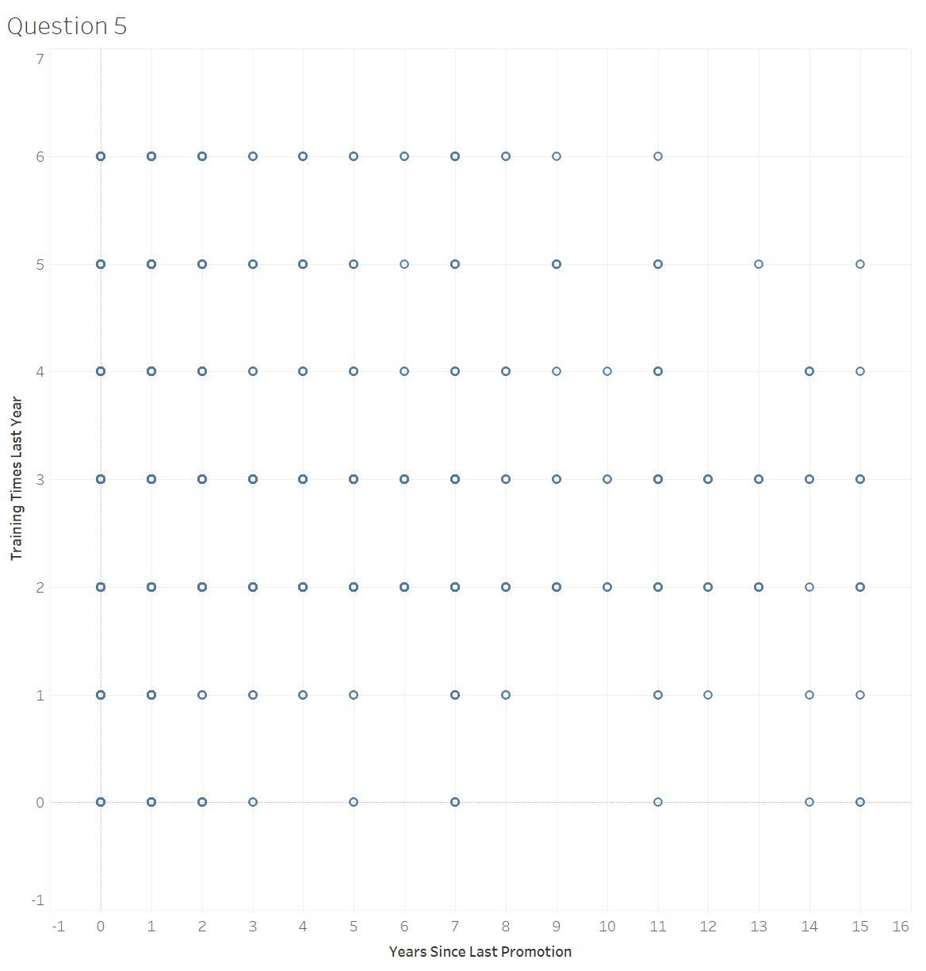

Go under the Analytics tab and click on Clusters. Drag it over onto your bar graphs.
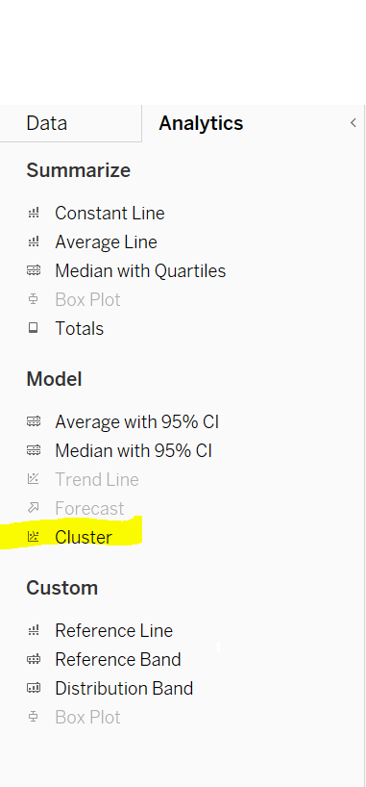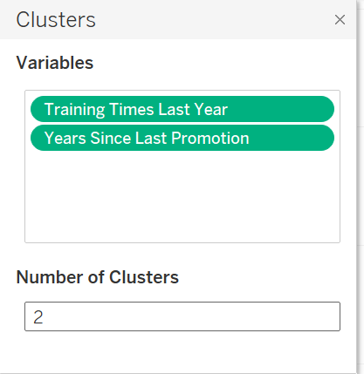

The Cluster window will pop up, you should see the two measures that you added earlier. Change the number of clusters to 2 and click on the x to close the window.

Clusters should be on the colors marks and you should now see your scatter plot with 2 different colors.
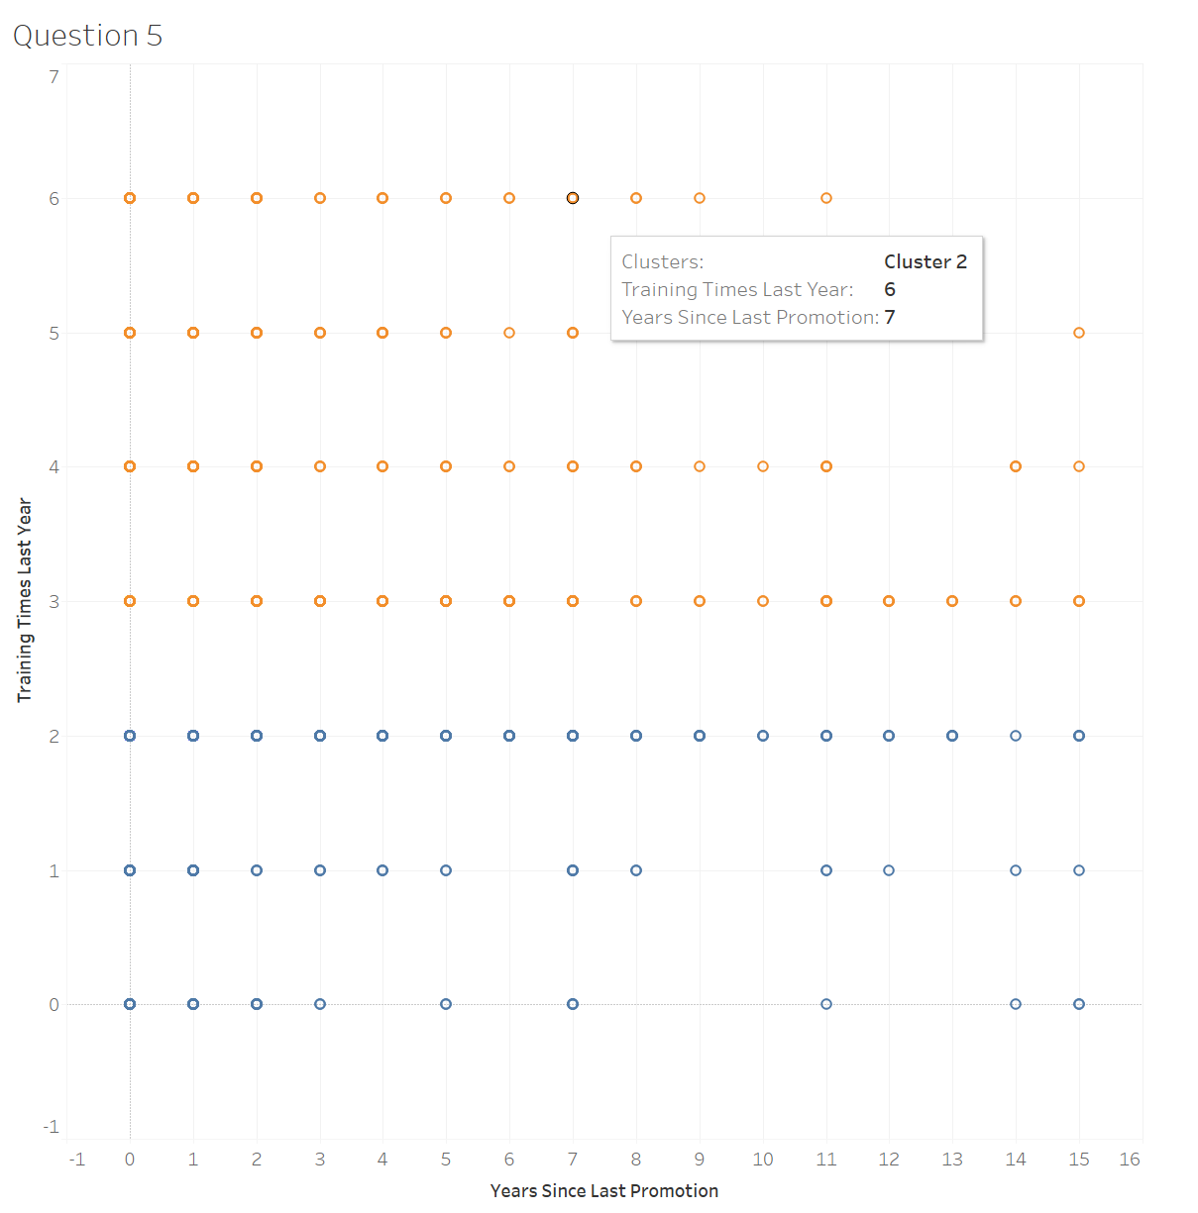
Next, right-click clusters in the marks area. Then click “Describe clusters”. 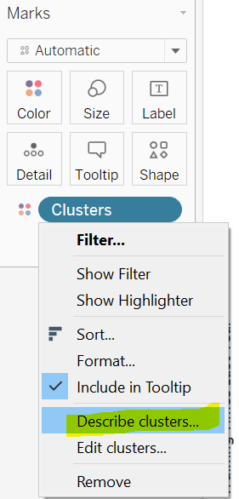

You should see a window pop up, drag the top left, and bottom right corners to make the screen bigger. You will see the information about the clusters you created.

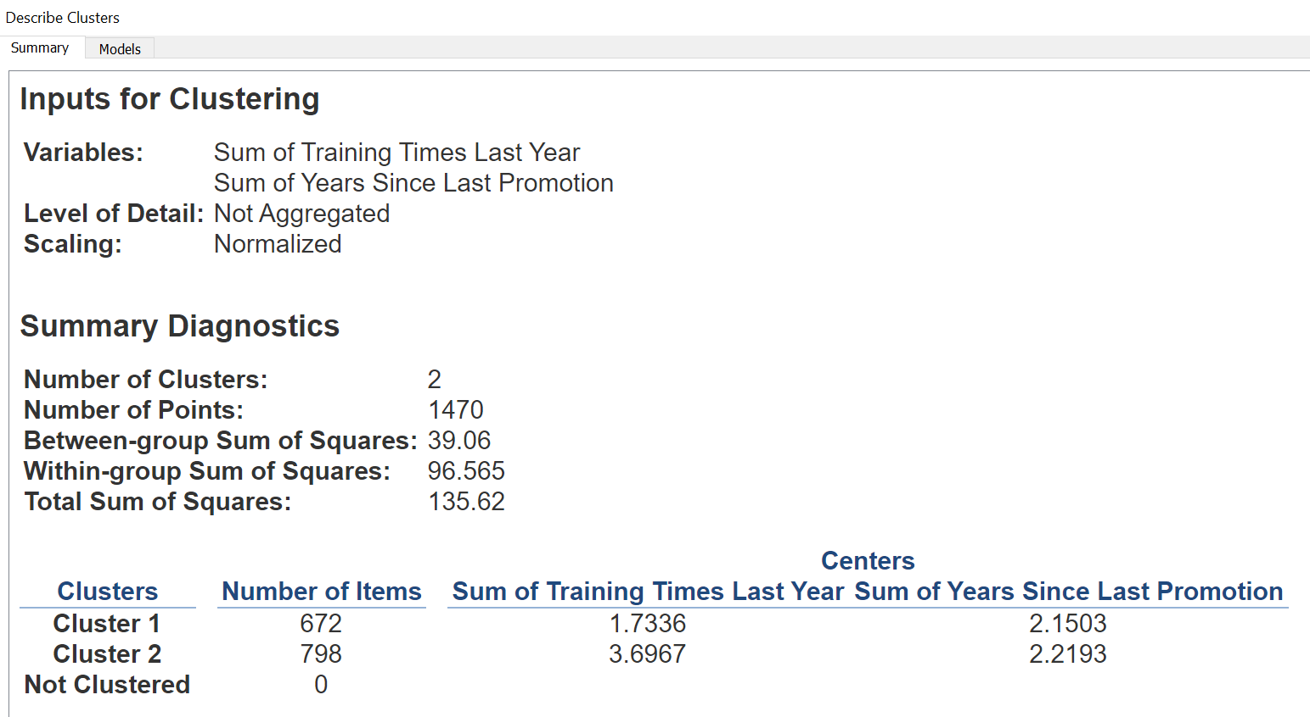

We can now tell the pharmaceutical how many employees are in each cluster. We can also tell them about the characteristics of the employees. Cluster 1 has 672 employees that have had low training sessions and a shorter time since their last promotion. The second cluster has 798 employees who have more training, but a slightly longer time since their last promotion.

The pharmaceutical company says that they have hired three success coaches in their organization, and they would like 3 clusters now. Follow the previous steps for creating clusters but use 3 instead of 2.

What is the “Sum of Years Since Last Promotion” for the third cluster?
Question 5 Answer: | 8.6277

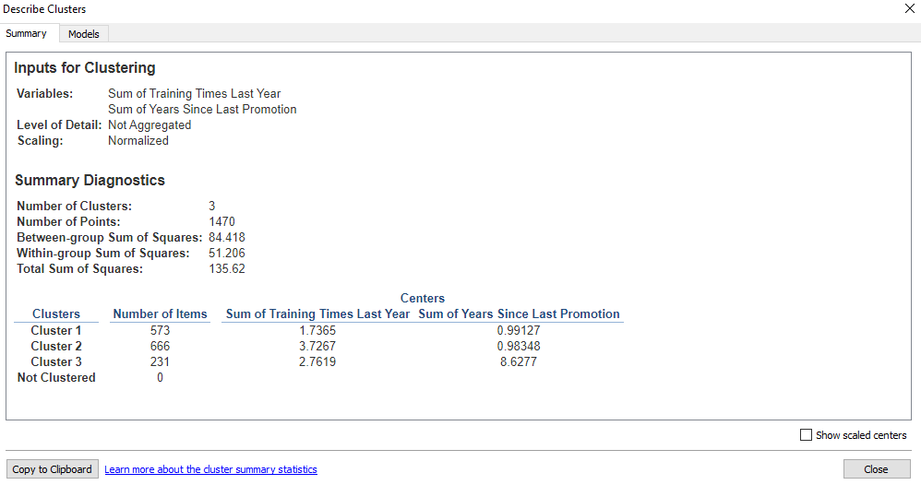

Question 6: Distribution

The pharmaceutical company has requested one more request, they would like to see the relationships between the variables “Years at Company” and “Monthly Income (USD)”. You will make a scatter plot just like in Questions 1, 3, and 4.

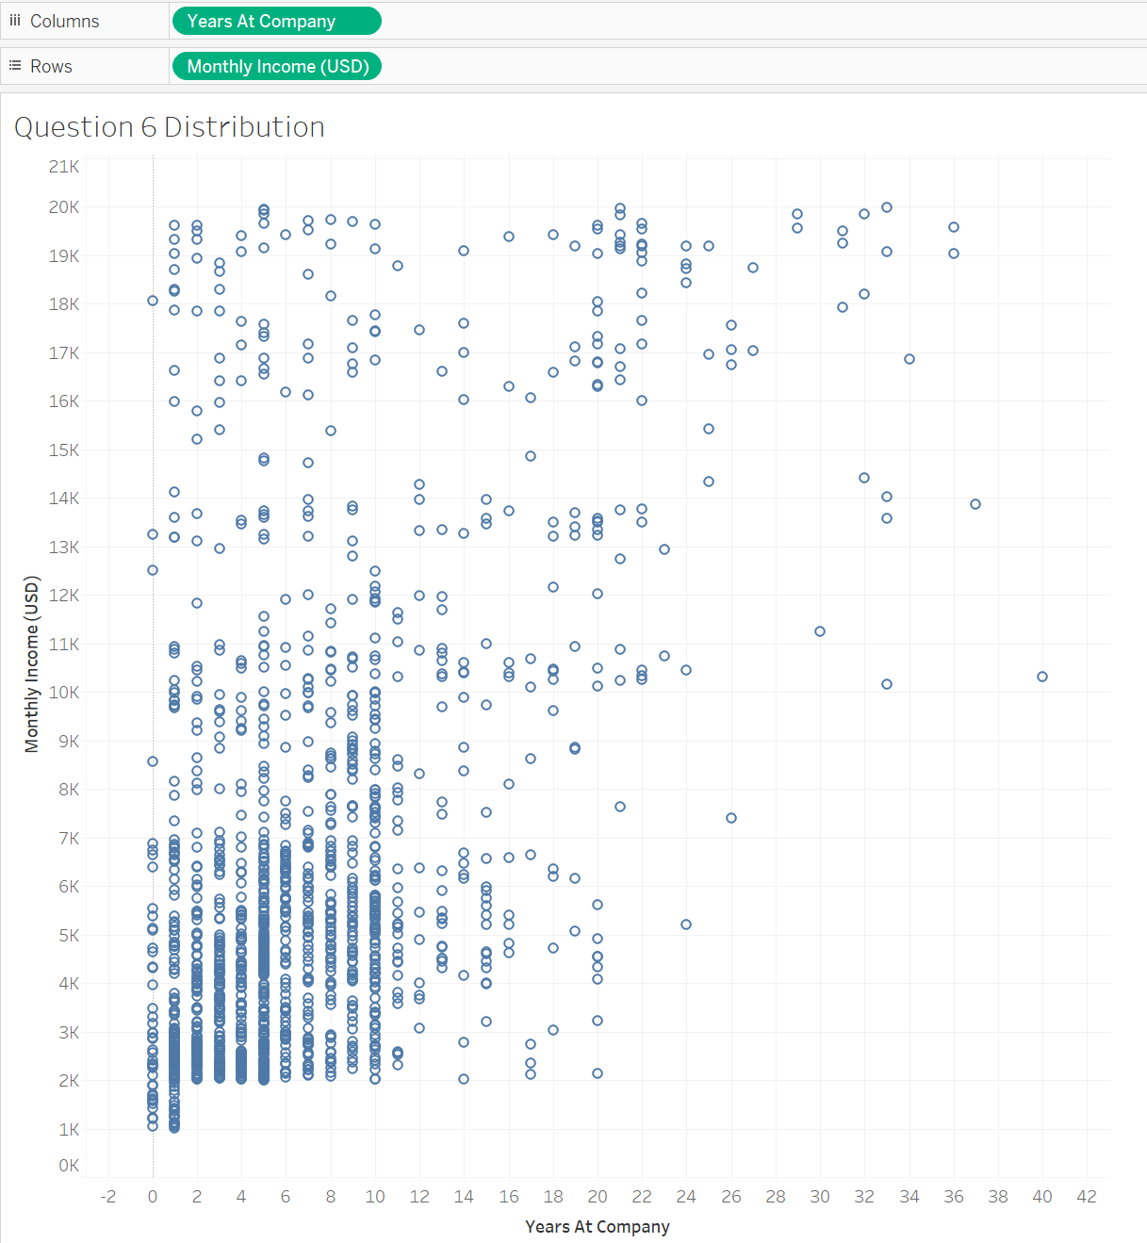
Click on the analytics tab and drag Distribution Band onto the scatterplot. Make sure it is for the whole table.

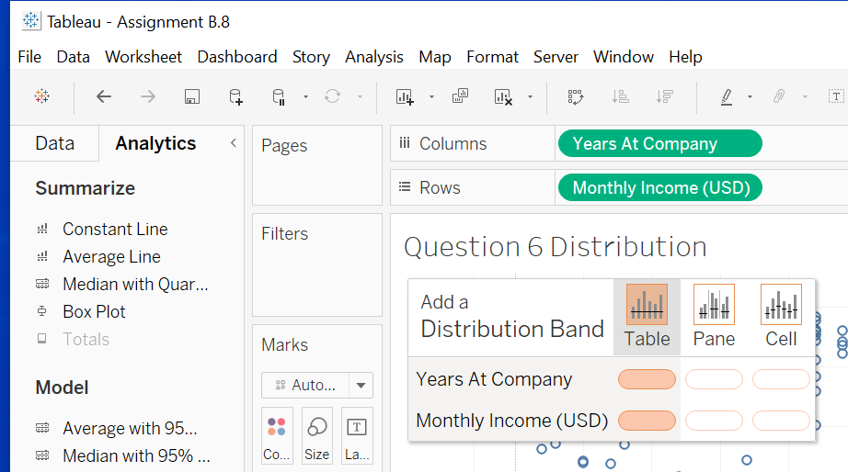

Use the default settings for the distribution bands. Click OK.

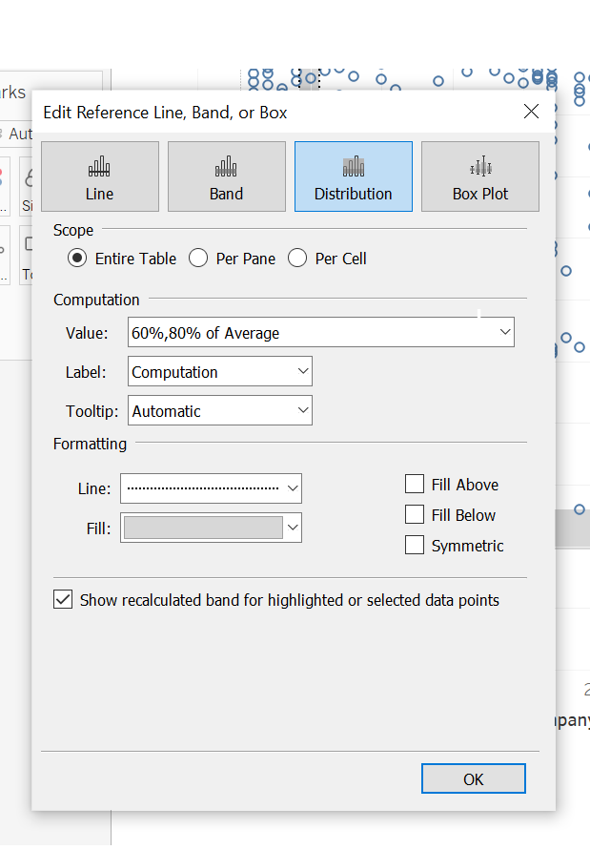

Hover over each distribution band. What are 60% of the average monthly income (rounded to the nearest whole number) and the 60% average of years at a company (rounded to one decimal place)?

Option A: $5,202, 4.2
Option B: $3,902; 4.2
Option C: $3,902; 5.6

Question 6 Answer: | Option B: $3,902; 4.2

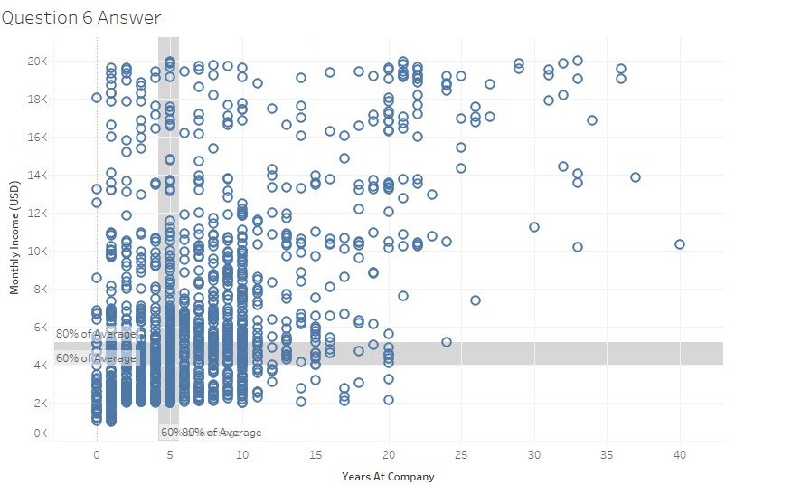

Question 7: Forecasting

Your analytics company just got a contract with the National Park Service. They are working on budget and resource planning for their Northwest parks located in Washington, Oregon, California, Hawaii, and American Samoa. They would like to know what future visitation will be. They have the last 20 years of visitor counts (B.8 NW National Park Visitation 2001-2020). They would like you to focus on Joshua Tree National Park, Olympic National Park, and Yosemite National Park.

After loading the data, hold down the “Park Name”, “Year”, and “Visitor Count” fields in the data pane (hold down the Ctrl button between each click). Click on the “Show me” menu and pick the Line Graph.
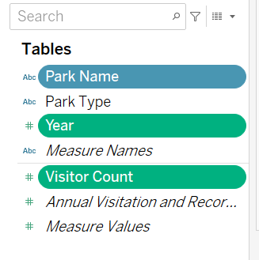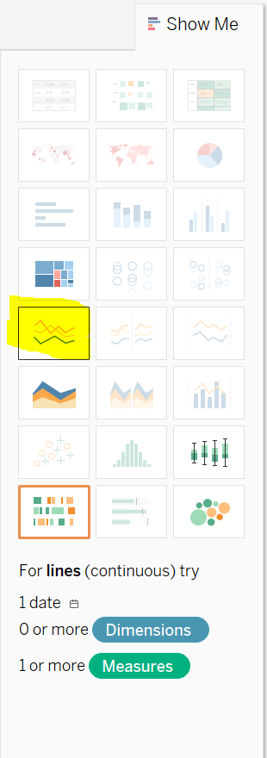

Now, drag the Park Name into the filter and select only Joshua Tree National Park, Olympic National Park, and Yosemite National Park.

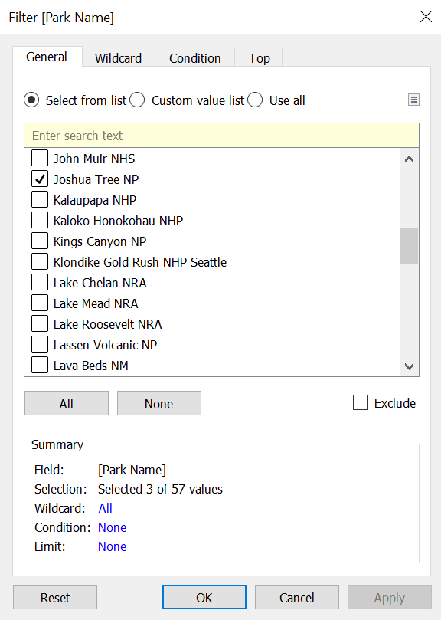

You should now see three-line graphs.
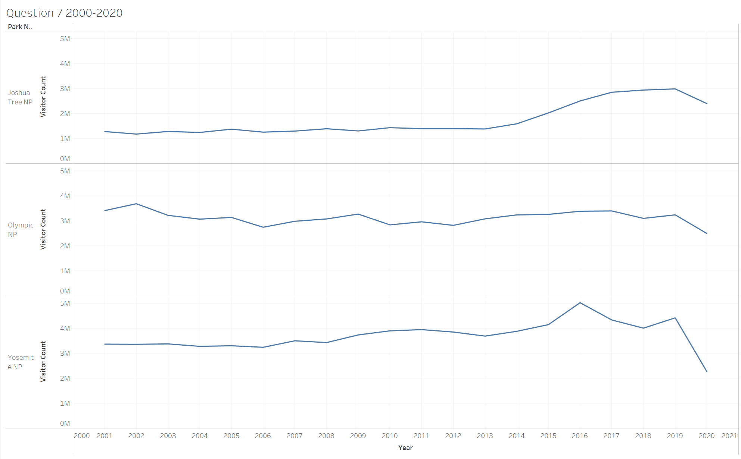

Next, click on the Analytics tab and drag the Forecast option onto the line graphs.
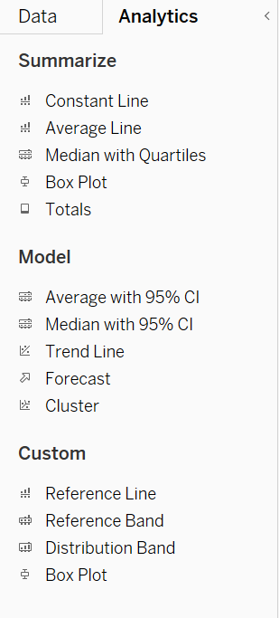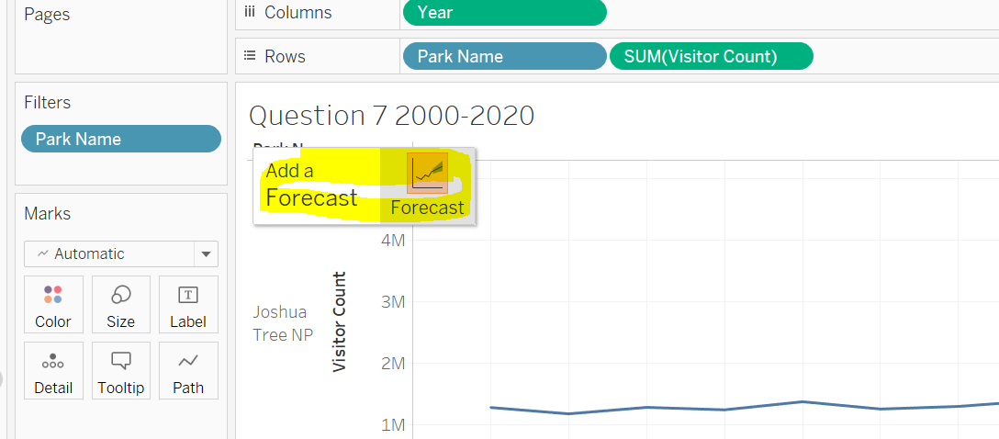

You should now see three forecasts created, one for each park.

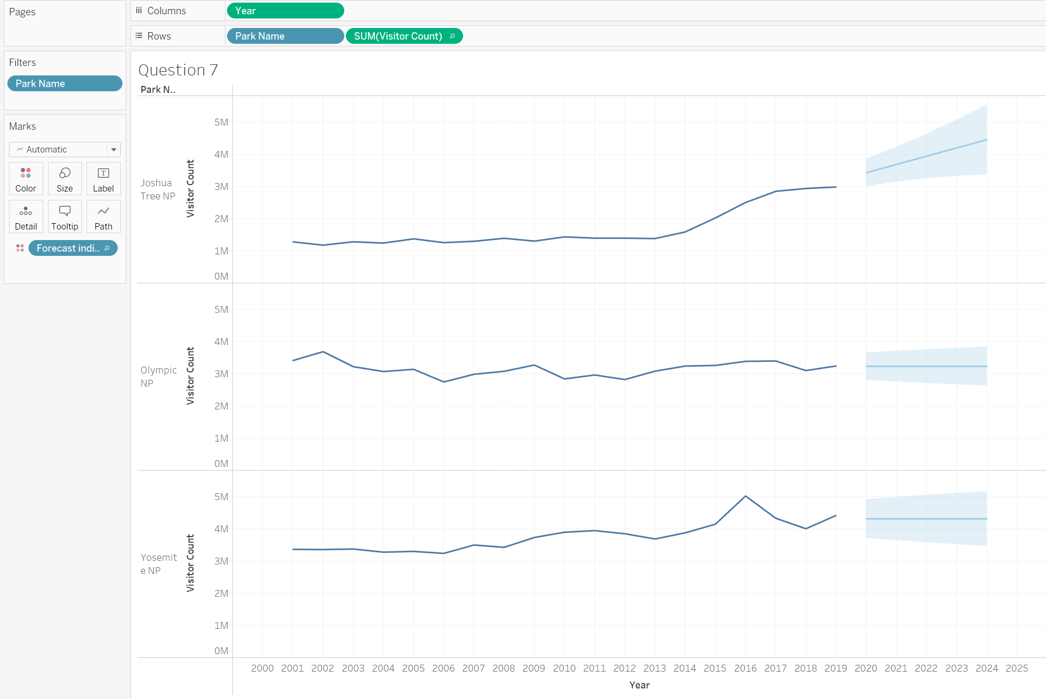

You will see that it gives a prediction, but also confidence intervals around the prediction (sometimes called the “prediction funnel”). The line gives the most likely values, but since the future is uncertain, it’s telling you it could be as high as the top of the funnel or as low as the bottom of the funnel.

You can see that Joshua Tree has a predicted increase, while Olympic and Yosemite are flat. Because of the COVID19 pandemic, you want to know how the 2020 year is affecting the prediction. There were lower visits that year and they don’t want them to affect their predictions for the future. Right-click on the forecast area. Select “Forecast” then “Forecast Options”.
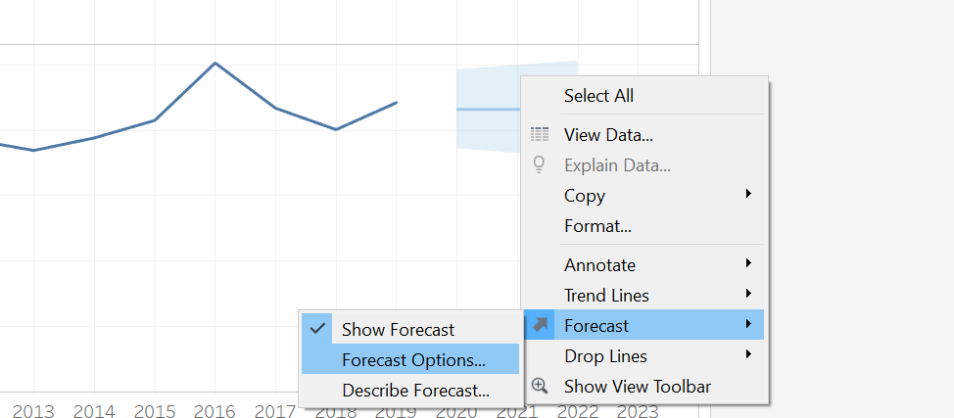

In the Forecast Options, you see the calculations behind the forecast. By default, Tableau ignores the last period, which just happens to be 2020. We can tell the Park Service that the 2020 numbers are not in the forecast. We can also assure them that we did ignore missing values (rather than fill in with 0) and we showed predictions in the 95% confidence level.
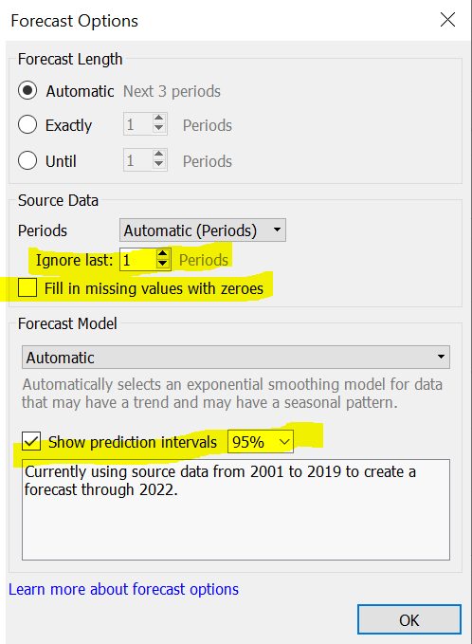
Change the forecast length to 5 years into the future. Do not fill missing values with 0 and use a 95% confidence level.
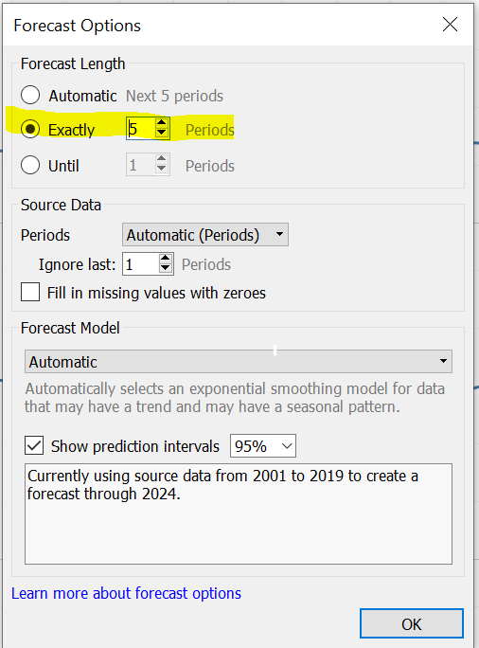

The National Park Service finds this very helpful and would now like you to do this for the following parks: “Hawaii Volcanoes NP”, “Kaloko Honokohau NHP”, and “Pearl Harbor NMEM”.

Which of the following matches the forecast of future visitors to the selected National Parks?

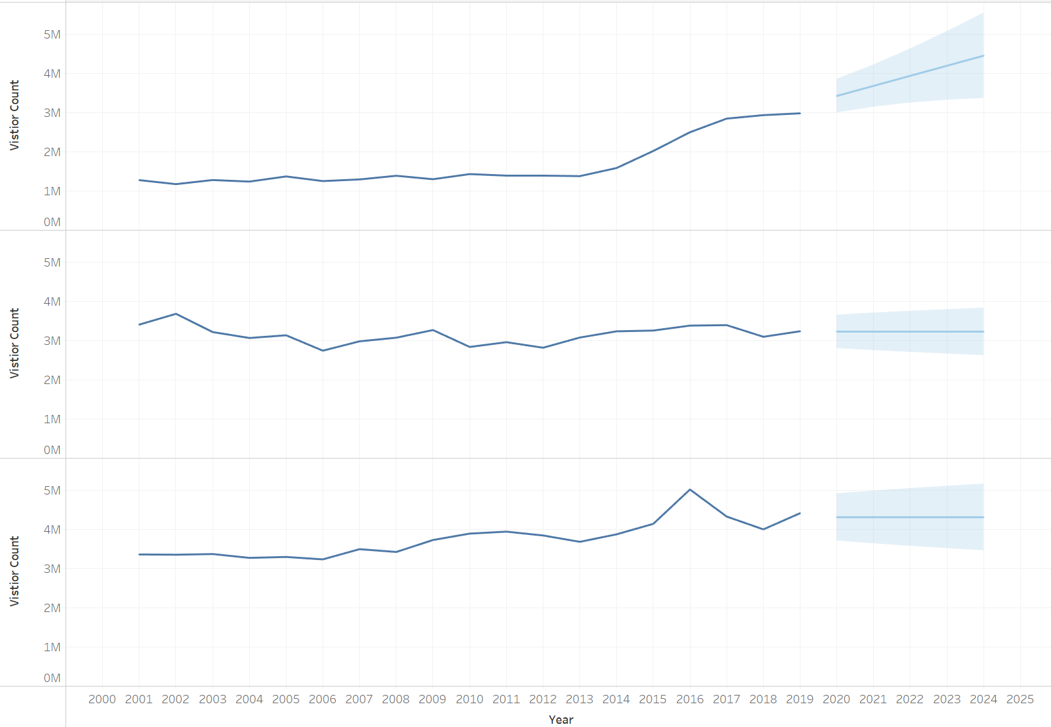  Option A | 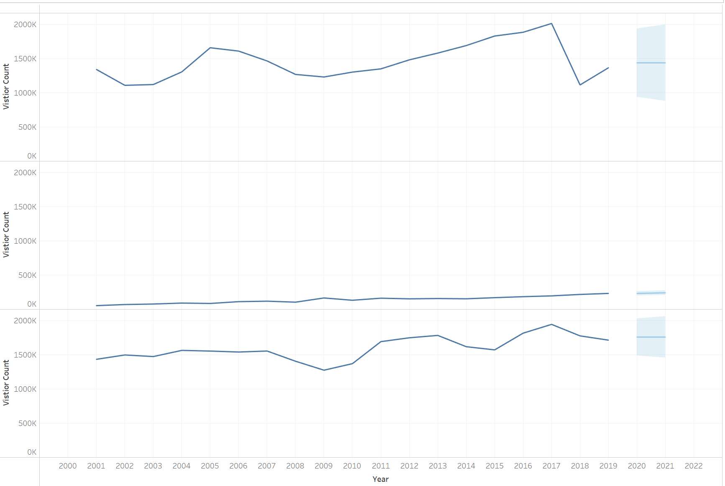  Option B
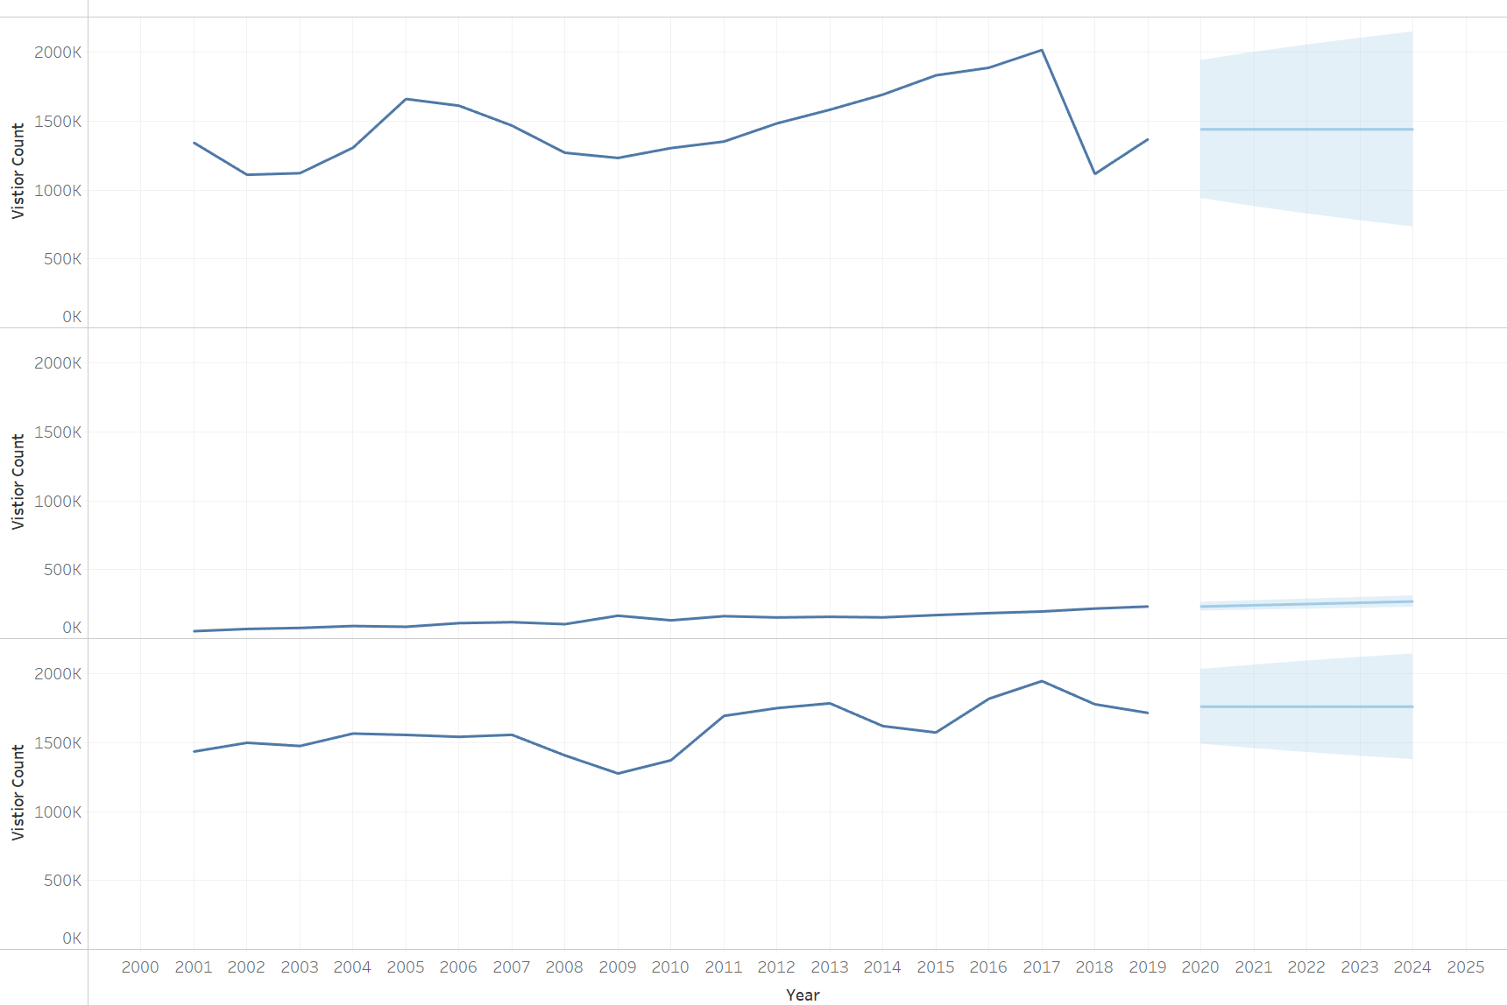  Option C | 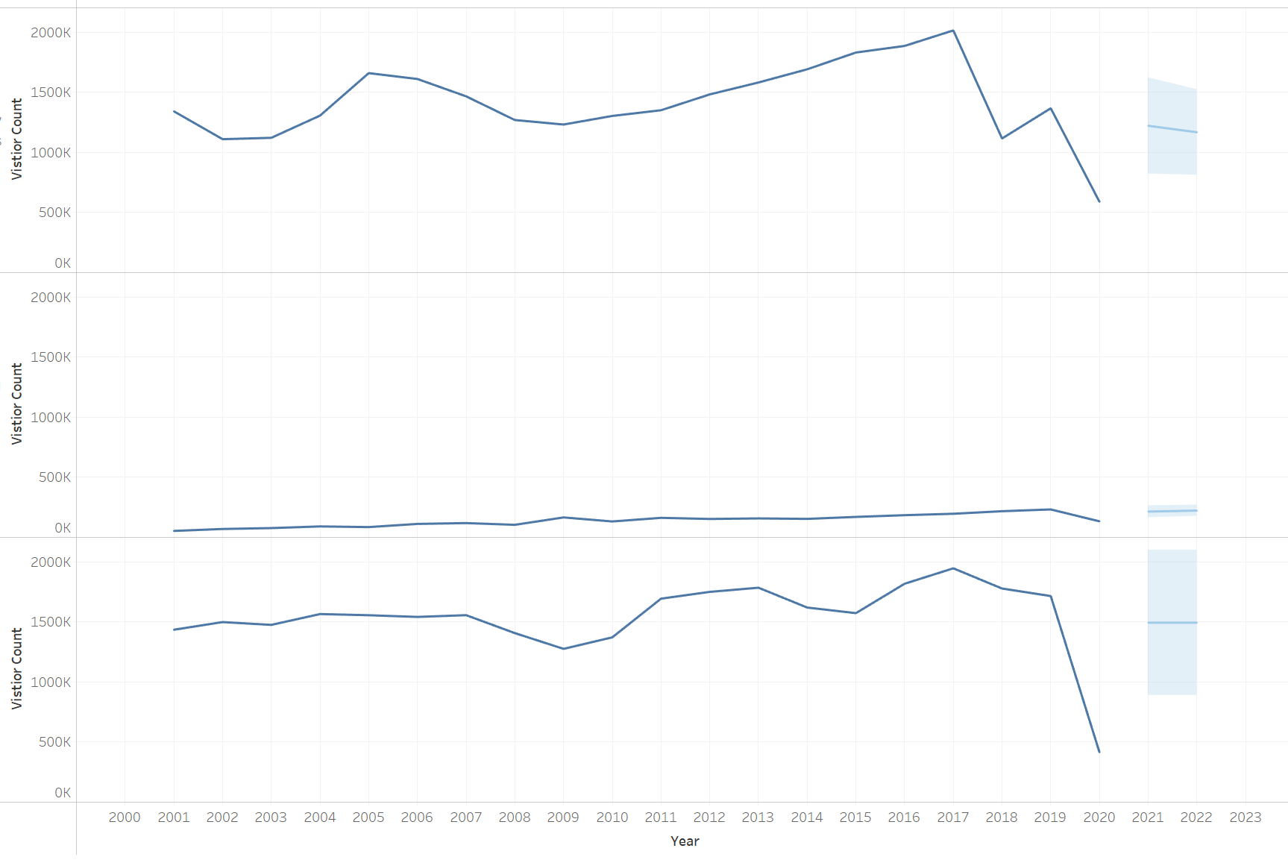  Option D

Question 7 Answer: | Option C



